Bonfires of Insanity: A History of Book Burnings From Nazis to ISIS

Burning Ideas
02.28.15
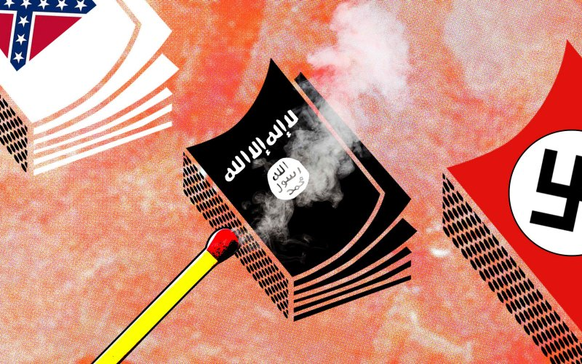
Burning books—and their authors—is perhaps the oldest form of censorship.
The latest outrage perpetrated by ISIS, the Islamic terrorist movement, is that they don’t just burn people; they burn books, too.
Last week ISIS members burned the Mosul public library, and along with it more than 8,000 rare old books and manuscripts. Across al Anbar province in western Iraq, local officials report the ISIS campaign has burned more than 100,000 titles.
And they haven’t confined their activities to books. ISIS thugs also destroyed 3,000-year-old statues at the Mosul museum and at an archeological site, smashing priceless antiquities with sledgehammers and power drills. This war on culture brings to mind the Taliban’s destruction of the standing Buddhas of Bamiyan in March 2001.
That such barbarous acts are being perpetrated in the birthplace of writing and of civilization itself makes them all the more tragic. But it hardly makes them unique.
It is not just the likes of ISIS, people who would have to progress 1,000 years to be considered medieval, which favor censorship by fire. Burning books—and in the past, their authors as well—that espouse hated ideas is perhaps the oldest form of censorship.
And it never seems to go out of fashion. This coming week on Nov. 5 (Guy Fawkes Day in the UK), a battered women’s refuge in England will be hosting a public book burning of Fifty Shades of Grey, calling it a manual for abuse. But some frustrated husbands in Ohio beat the shelter to the punch (so to speak), having torched copies of the mommy-porn novel on the ground that their wives were too busy reading the steamy book to pay attention to them in the bedroom.
Historical examples of book burning are too numerous to list in a short article, but they date back to antiquity. The Babylonians and their allies burned the library of the scholar King Ashurbanipal in 612 BC when they sacked the Assyrian capital of Nineveh. In 213 BC Chinese Emperor Qin Shi Huang ordered the burning of all history and philosophy books from states other than Qin (in addition to burying intellectuals who disputed state dogma). And the works of the Greek philosopher Protagoras were gathered and burned in the marketplace in Athens because he dared to question whether the gods exist.
Although religion is far from the only motive for book burnings, a belief in the supernatural often is what fans the flames. In 168 BC, Antiochus IV ordered Jewish books in Jerusalem be “rent to pieces” and burned. The Emperor Constantine ordered the burning of works by those who disputed the Trinity. The Christian Emperor Jovian burned the library of Antioch in 364 AD, because it had been stocked largely by Emperor Julian who was non-Christian; and in 392 AD, the library at Alexandria was looted and burned by Christian mobs and the woman philosopher Hypatia murdered.
The religious conflicts that divided Europe in the Middle Ages (and beyond) continued the tradition of book burning. In 1242, Pope Gregory IX prevailed on King Louis IX to destroy all copies of the Talmud in Paris. About 12,000 volumes were burned after being “tried” by the crown and “convicted.” In 1401, the English Parliament under King Henry IV passed a law entitled “On the Burning of Heretics” that required the collection and public burning of heretical works. In the decade before 1500, the Spanish Inquisition ordered the wholesale burning of Jewish and Arabic texts. In 1499, for example, the Archbishop of Toledo publicly burned 5,000 Arabic manuscripts in Granada’s public square. By order of the Pope, Martin Luther’s German translation of the Bible was burned in 1624 in those parts of Europe controlled by Catholics (although for his part, Luther himself burned Papal decrees).
“What progress we are making. In the Middle Ages they would have burned me. Now, they are content with burning my books.”
Of course, it wasn’t just books that were consigned to the flames. A common punishment for heresy was to be burned at the stake along with the offending works. For example, the Inquisition in Rome condemned the heretic Cecco d’Ascoli to such a fate in 1328 for his book De Sphaera, and such was the practice for hundreds of years. The Calvinist-dominated City Council of Geneva in 1553 ordered that Michael Servetus be burned at the stake with his manuscript along with a copy of a printed book tied to his waist. His crimes? Preaching non-trinitarianism and opposing the baptism of infants.
In the 20th Century, book burning is most closely associated with Nazi Germany, and for good reason—the Nazis wanted to be known for it. On May 10, 1933, Nazi youth groups burned some 25,000 “degenerate” books at a large bonfire in Berlin, with radio broadcasts to publicize the event to those who could not attend in person. Books by such authors as Albert Einstein, Bertolt Brecht, Helen Keller, Sigmund Freud, Thomas Mann, Karl Marx, Ernest Hemingway, and H.G. Wells were tossed on the flaming heap. Similar events were held throughout Germany in the 1930s and ’40s, and 40,000 people attended a speech by Joseph Goebbels describing the events.
Freud would later quip, “[w]hat progress we are making. In the Middle Ages they would have burned me. Now, they are content with burning my books.” But Freud probably is fortunate he didn’t stick around in Vienna after the Nazis annexed Austria to find out it that was true.
Book burning isn’t associated as much with the United States, given our unique First Amendment protections, but even in this country, it is a well-established tool among the champions of censorship. From the colonial period, William Pynchon’s book The Meritorious Price of Our Redemption was banned in 1651 for criticizing the Puritans, and all known copies were publicly burned.
Book burning became institutionalized in the late 19th Century after Anthony Comstock persuaded Congress to adopt a federal obscenity law in 1873. Comstock, who headed the New York Society for the Suppression of Vice, made no bones about his purpose. The seal for the New York Society depicted on one side a constable ushering a miscreant to jail, and on the other, a Victorian gentleman stoking a large fire with armloads of books.
The law Comstock promoted, and which he helped enforce as a special agent of the Post Office, banned any book or other item even remotely related to sex, including information on contraceptives. And Comstock kept close track of the material he seized and destroyed—usually by fire. By the time he died in 1915, Comstock claimed to have burned some 15 tons of books, as well as 284,000 pounds of printing plates for “objectionable” texts (which were melted down), and nearly four million pictures. While he didn’t set the authors ablaze as did his predecessors, Comstock boasted that he drove a number of writers and booksellers to suicide.
Official book burnings faded away as the Supreme Court developed a strong First Amendment jurisprudence in the mid-to-late 20th Century. But “unofficial” book burnings persist. In 1948, stoked by pseudo-scientific theories that blamed juvenile delinquency on comic books, a number of communities around the country held public burnings of comics. The obvious parallel to Nazi Germany apparently was lost on the organizers.
Similarly, in 1966 a number of communities across the Bible Belt in the southern U.S. publicly burned Beatles records in reaction to an out-of-context John Lennon quote that the band was “more popular than Jesus.” Evangelists, some southern disc jockeys, and the Ku Klux Klan urged people to bring records and band merchandise to throw on the bonfires at anti-Beatles rallies. And so they did.
Did the Beatles cease to exist as a result, or become less popular than Jesus? Of course not (although 1966 marked their last tour as a band). But burning is a peculiar form of censorship in that the act itself is intended to send a message. This is why book burning is a public spectacle. It is designed to express outrage and contains within it the notion that the ideas contained in the books or other works of art should be obliterated entirely.
In less enlightened times—a place where ISIS still lives—it was more possible to believe that ideas could be assassinated along with their authors. But even in ancient times, the censor’s power was limited.
The Arab philosopher Averroes, who was largely responsible for preserving the legacy of Aristotle in Western thought, fell out of favor with the ruling authorities at the end of the 12th Century, and his writings were ordered to be burned. As he stood watching the blaze, he told one of his students who was openly weeping, “Today I cry over our situation . . . but the ideas have wings.”

